ASME

Website Application

Functional Requirements Document

Dec 24, 2018

By Abhijeet Bhujbal

Project Manager, CTS

[Abhijeet.Bhujbal@aptaracorp.com](mailto:Abhijeet.Bhujbal@aptaracorp.com)

o: (India): +91.20.6672.8000 x8114

m: +91.989.048.7115

Table of Contents

1.0 Purpose 4

2.0 Description 4

Register Contributor 4

Login 6

Forgot Password 6

Home 7

Chapter - Edit Mode 8

Chapter - Review (for Editor) 10

**VERSION CONTROL SHEET**

|  |  |  |  |
| --- | --- | --- | --- |
| **SOW Name** | **Version No.** | **Date** | **Created By** |
| Functional Requirements Document | 1.1 | Dec 24, 2018 | Abhijeet Bhujbal |

# 1.0 Purpose

ASME needs the content authoring application which will allow editors to invite contributors to update the existing three chapters and help create a brand new fourth chapter.

# 2.0 Description

The user roles using the application will be as mentioned below:

1. Editor
2. Contributor

## Register Contributor

## 

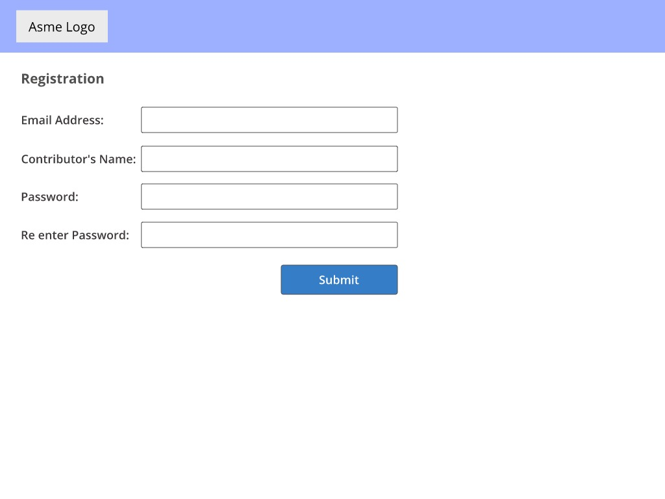

* A registration link will be provided to ASME which they will email to the contributors
* As a contributor I will be able to:
  + Click on the link, to be taken to the “Accept Copyright” page where I will be required to mention my name, date and “Accept” to proceed.
  + On clicking on “Accept” I will be taken to the registration page, mention my name, email address, password and re-enter password.
  + When I click on “Submit” button I will be taken
  + I will now be able to login into the application using the email address mentioned by the editor and the password set by me.

Note:

1. As a contributor
   1. I will be not be able to proceed unless I accept the Copyright
   2. I will be able to forward this email link to another contributor, who will be able to register too.

## Login

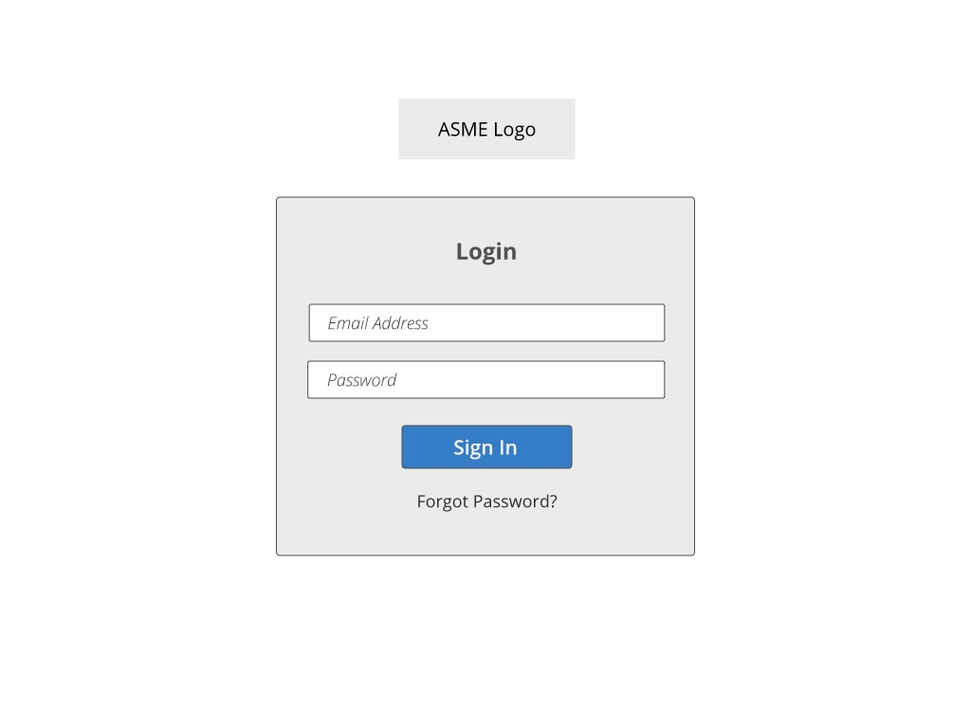

* As a Contributor or Editor I will be able to Login by entering the correct details and clicking the “Sign In”button
* On Successful Sign in I will be taken to the Home Screen

Note:

* In case, the email address does not exist in the database, I will get an error message stating “The email address and password do not match”

## Forgot Password

* As a Contributor or Editor I will be able to reset my password by clicking on the “Forgot Password” in the login screen. The steps to reset my password are as follows:
  + Enter the registered email address to receive a link on the mentioned email address.
  + I will click on this link to be taken to the Reset Password screen in a new tab.
  + Enter and re-enter a new password and click on the Save button.
  + On clicking on Save Button, this new password will be saved and I will be taken to the Login screen to sign in.

Note:

* The password will be of at least 8 characters and should comprise of at least one alphabetic and numeric character.

## Home

Home Screen for a contributor

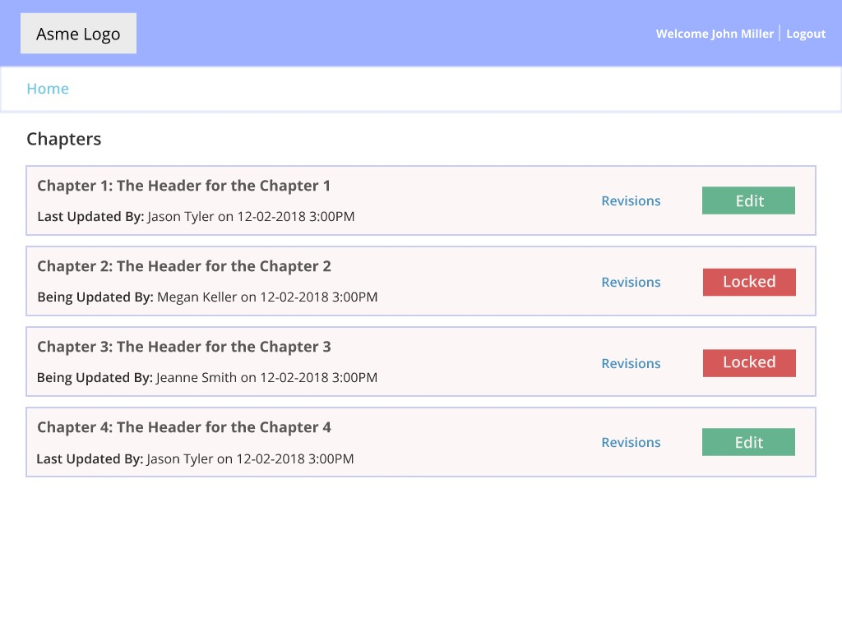

Home Screen for an editor

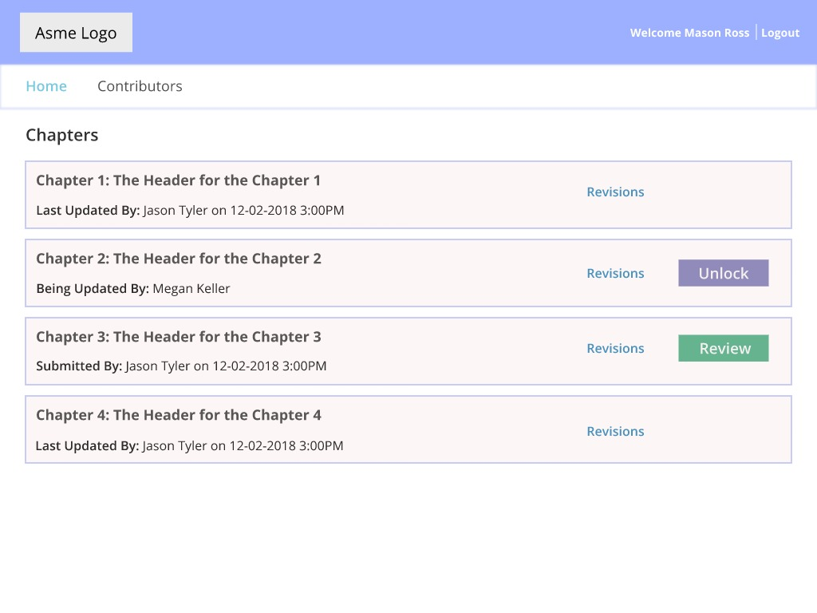

* The Home screen will display a list of all the chapters in the book. This screen will be available for both Editor and Contributor.
* I will be able to click on a chapter’s name to view its last published version in a new tab.
* As an Editor:
  1. I will be able to see the contributor’s name and the date of the submission for a recently submitted chapter.
  2. I will click on the “review” to be taken to the Chapter Edit screen.
  3. I will also be able to release a locked chapter by clicking on the “Release” button. This will make the chapter available for review.
* As a Contributor:
  1. I will click on edit link for a chapter with status available to start editing it - I will be taken to chapter edit page.
  2. The chapter will available to me to edit for a predefined duration.
  3. To see the past revisions of the chapter I will click on the “Revision” link - which will display a list of all the revision of the chapter.

Note:

* After the predefined duration, the chapter will be automatically available to the editor for review.
* The chapter will remain locked for other contributors until the editor reviews and publishes the new version.

## Chapter - Edit Mode

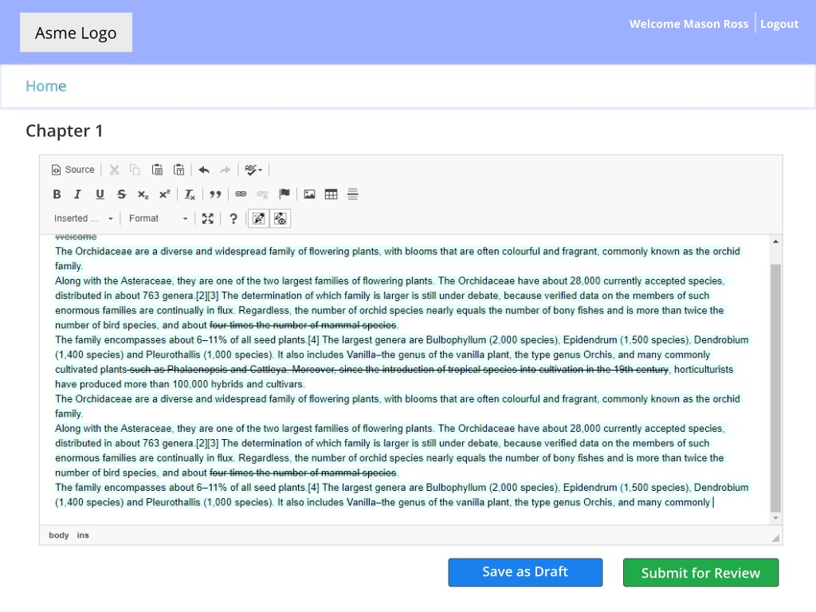

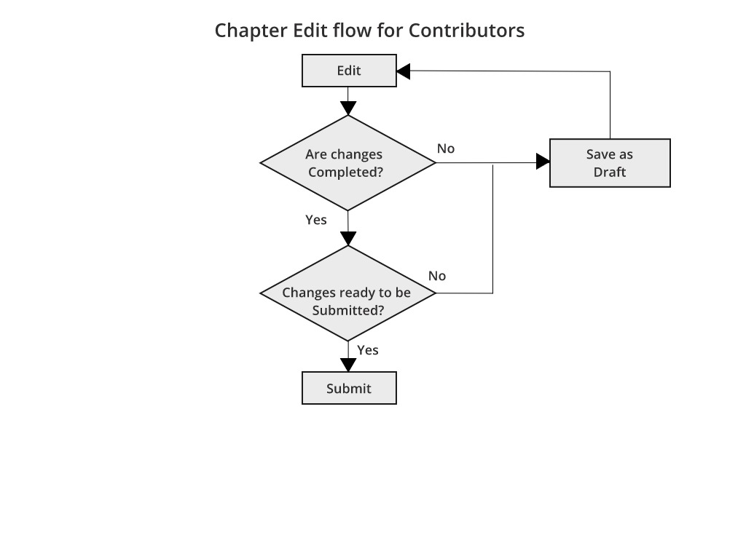

* The screen will comprise of the name of the chapter I am editing as a contributor.
* As a Contributor I will have an option to save the current draft or submit changes for review.
* In the text editor my edits will appear as:
  1. Strikethrough - For text removed
  2. Highlighted - For text added

Note

* The changes will be automatically saved for each chapter, so that when I login the next time, I can start from where I left off.
* The changes will not be available to the reviewer unless I submit for review.

## Chapter - Review (for Editor)

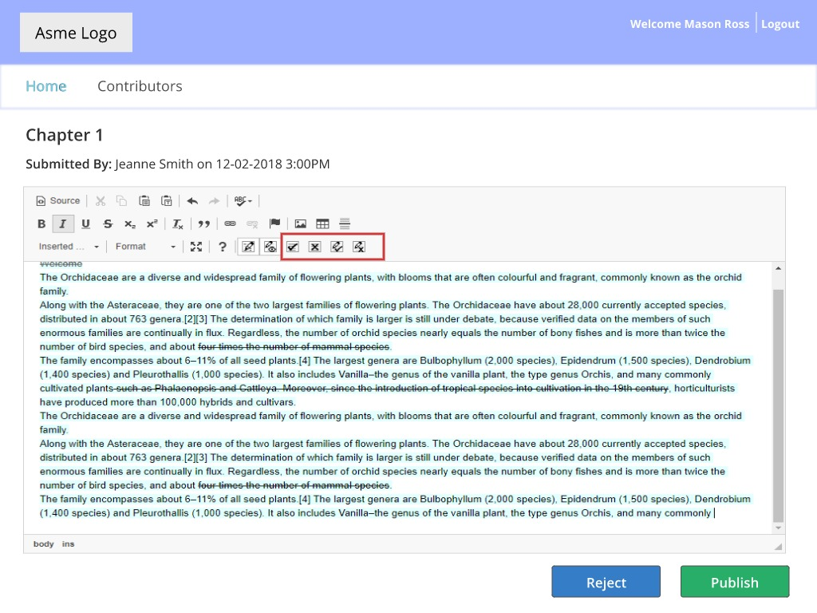

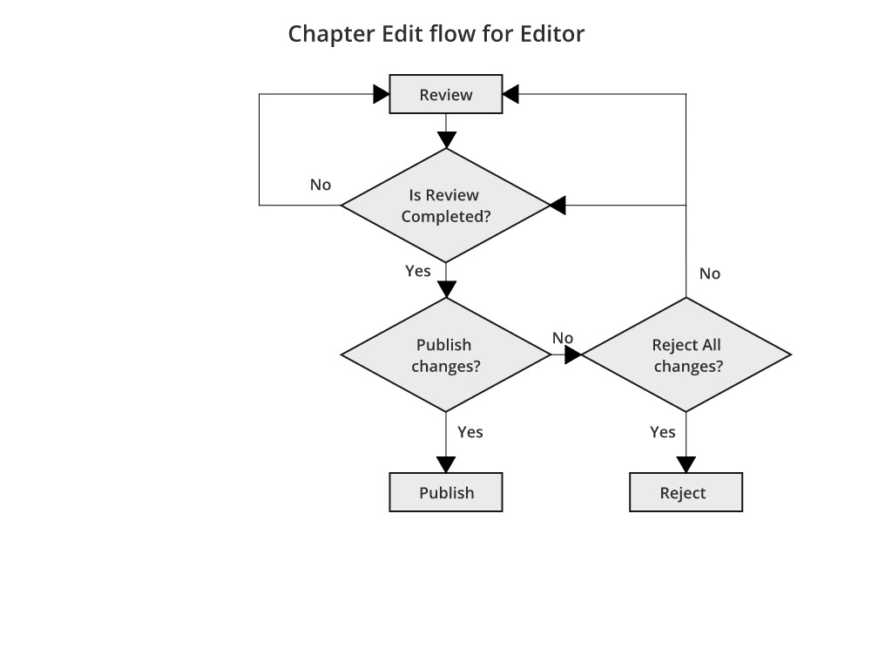

* As an Editor
  + I will have an option to accept or reject individual changes or all the changes mentioned.
  + I can accept / reject all the changes done by the contributor by clicking on the “Accept All” button or “Reject All” button.
  + On completion of the review I will have the option to “Publish” or “Reject” the document.